e-ISSN: 2829-9760
Journal of Health and Nutrition Research
Vol. 4, No. 1, 2025, pp. 1-10, https://doi.org/10.56303/jhnresearch.v3i3
Journal homepage: https://journalmpci.com/index.php/jhnr/index

Title of Manuscript Journal of Health and Nutrition Research (Font Cambria 13 bold)
First Author^{1*}, Second Author² (Font Cambria 11 Bold)

¹ Department, University, City, Country (Font Cambria 10), email,
² Department, University, City, Country (Font Cambria 10), email

Corresponding Author Email:

Copyright: ©2025 The author(s). This article is published by Media Publikasi Cendekia Indonesia.

ORIGINAL ARTICLES |  | ABSTRACT
Submitted:  Accepted: |  | Detailed instructions for preparing your paper submitted to Journal of Health and Nutrition Research are given as follows. Please be responsible for the quality and appearance of your work. It’s strongly recommended that you directly type over the template or just cut and paste from another document and use markup styles. Please keep in mind through the preparation: do not modify page setup in this template, such as font, line spacing, margin, uppercase and lowercase, and the order of sections. The abstract section is mandatory, with a word limit of 200-250 words. The purpose, methodology, results & conclusions, and implications should be summarized here. Avoid inserting any reference in this section. (Cambria font size 10 pt with 1.15 spacing). Detailed instructions for preparing your paper submitted to Journal of Health and Nutrition Research are given as follows. Please be responsible for the quality and appearance of your work. It’s strongly recommended that you directly type over the template or just cut and paste from another document and use markup styles. Please keep in mind through the preparation: do not modify page setup in this template, such as font, line spacing, margin, uppercase and lowercase, and the order of sections. The abstract section is mandatory, with a word limit of 200-250 words. The purpose, methodology, results & conclusions, and implications should be summarized here. Avoid inserting any reference in this section. (Cambria font size 10 pt with 1.15 spacing)
Keywords:
keyword 1, keyword 2, keyword 3, keyword 4, keyword 5
Keywords section, please enter words or phrases in alphabetical order. There is a maximum of 5 keywords



This work is licensed under a Creative Commons Attribution-NonCommercial-ShareAlike 4.0 International License

Access this article online    Quick Response Code |  | Key Messages:  - Write 2-5 key messages related to this study  - Key messages may relate to applicability, novelty, and/or impact of the research. (Cambria font size 10 pt with 1.15 spacing)

Graphical Abstract

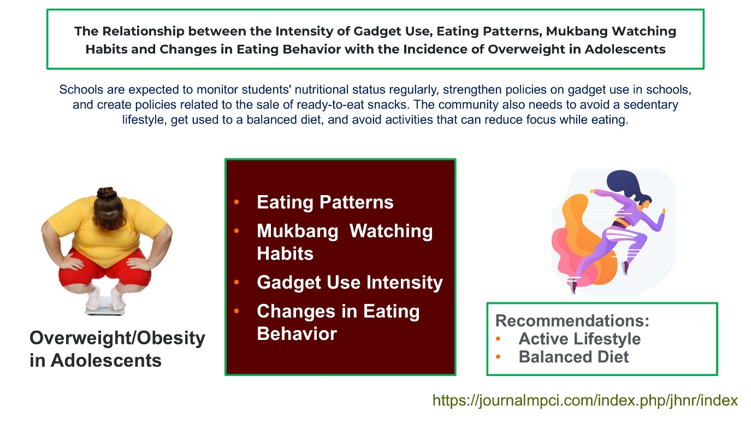
Download template Graphical Abstract (PPT): https://docs.google.com/presentation/d/1Zz2XjOWwc8uQtzfIRBuGnEaiz31LRUXA/edit?usp=sharing&ouid=106743988417812157892&rtpof=true&sd=true

Introduction
The introduction should briefly place the study in a broad context and highlight why it is important. It should define the purpose of the work and its significance. The current state of the research field should be carefully reviewed and key publications cited. Please highlight controversial and diverging hypotheses when necessary.
Finally, briefly mention the main aim of the work and highlight the principal conclusions. The introduction should discuss the background of the research, the rationale and the research questions and/or aims(1). In this section(2), the current evidence on the topic should be discussed to subsequently be related to the research gap that would be addressed by the research. (Cambria font size 10 pt with 1.15 spacing).
Provide sufficient background and context.
Identify shortcomings or gaps in existing knowledge.
Clearly state research objectives or aims.

METHODS
This section should include the research design applied(3), context, subject and sampling, data collection tools, data analysis and the steps of the research(4). Please also state the ethical clearance attributes of the study. New methods and protocols should be described in detail while well-established methods can be briefly described and appropriately cited. (Cambria font size 10 pt with 1.15 spacing).
Research design must be well-defined.
Methods and materials must be described in sufficient detail for replication.
Sample size must be adequate, and sampling methods must be described.
Relevant tools, instruments, or software must be clearly described, including their sources and versions.
Data collection and analysis methods must be appropriate.
Ethical considerations must be addressed (e.g., informed consent, ethical approval).

CODE OF HEALTH ETHICS
If research is directly related to patients, and uses test animals in research. Please attach a research code of ethics related to your article. (Cambria font size 10 pt with 1.15 spacing).

RESULTS
Results may be presented using tables, charts/figures/flowcharts or transcripts.
Results must be presented clearly and logically.
All relevant data must be included.
All tables and figures must be cited consecutively in the text.
Table 1. Example of table presentation
Title 1 | Title 2 | Title 3
entry 1 | data | data
entry 2 | data | data

The text continues here (Figure 1).

Figure 1. Example of figure/chart/flowchart presentation.

DISCUSSION
Authors should discuss the results and how they can be interpreted from the perspective of previous studies and of the working hypotheses(5).
The findings and their implications should be discussed in the broadest context possible.(6). (Cambria font size 10 pt with 1.15 spacing).
Research findings must be discussed in the context of the research question and literature.
Authors must contrast their findings with existing research in the field.
Critical analysis of the results, including limitations and potential biases, must be present.

CONCLUSION
Authors are expected to provide a brief conclusion to recap the information in the previous sections. It is recommended that the conclusion is presented in narratives rather than bullet points.
Authors are suggested to provide recommendation for further practice and research based on the current research. It is recommended that the recommendation is presented in narratives rather than bullet points. (Cambria font size 10 pt with 1.15 spacing)

FUNDING
Please add: “This research received no external funding” or “This research was funded by NAME OF FUNDER, grant number XXX” and “The APC was funded by XXX”

ACKNOWLEDGMENTS
In this section, you can acknowledge any support given which is not covered by the author contribution or funding sections. This may include administrative and technical support, or donations in kind (e.g., materials used for experiments).

CONFLICTS OF INTEREST
Declare conflicts of interest or state “The authors declare no conflict of interest.”

REFERENCES

The amount of literature cited should be sound but reasonable and it is expected that 80% of them are current literature of the last 10 years. Please use Vancouver citation style (Mendeley or Zotero).

1. Nuryani, Muhdar IN, Ramadhani F, Paramata Y, Adi DI, Bohari. Association of Physical Activity and Dietary Patterns with Adults Abdominal Obesity in Gorontalo Regency, Indonesia: A Cross-Sectional Study. Current Research in Nutrition and Food Science Journal. 2021 Apr 16;9(1):280–92.
2. Abdul Khalil HPS, Hossain MdS, Rosamah E, Azli NA, Saddon N, Davoudpoura Y, et al. The role of soil properties and it’s interaction towards quality plant fiber: A review. Renewable and Sustainable Energy Reviews. 2015 Mar 1;43:1006–15.
3. Alvin A. Arens, Randal J. Elder. Auditing dan Jasa Assurance: Pendekatan Terintegrasi. Jakarta: Erlangga; 2010.
4. Aini S. Efektivitas Program Pengelolaan Penyakit Kronis (PROLANIS) pada Penderita Hipertensi di UPT Puskesmas Tangkahan Durian Kabupaten Langkat Tahun 2019 [Internet] [Skripsi]. [Medan]: Universitas Sumatera Utara; 2021 [cited 2022 Apr 14]. Available from: https://repositori.usu.ac.id/handle/123456789/31959
5. Adams GG, Imran S, Wang S, Mohammad A, Kok S, Gray DA, et al. The hypoglycaemic effect of pumpkins as anti-diabetic and functional medicines. Food Research International. 2011 May 1;44(4):862–7.
6. Mulyani S. Maternal Health Literacy Towards the Readiness of Exlusive Breastfeeding. In: Internasional Seminar on Global Health (ISGH) 2017. Cimahi: Stikes Jenderal Achmad Yani Cimahi; 2017. p. 117–21.

